

EOL Test Fixture Screen Guide
  - Rite-Hite EOL Test Fixture Documentation

This guide explains what the technician sees on the EOL Test Fixture touchscreen and in the EOL Export Software app, including what action is required at each point.
Use this with EOL Test Fixture User Manual, EOL Test Fixture Test Procedure, and EOL Test Fixture Troubleshooting Guide.

Color Meaning

Fixture Touchscreen
Color | Meaning
Black | Pending or Not Yet Reached
Yellow | Active Test Item or Operator-Attention State
Green | Passed
Red | Failed

Desktop App One Click Test Progress Rail
Color | Meaning
Red | Currently Active One Click Test Stage
Green | Completed stage
Gray | Not Started Yet

EOL Test Fixture Screens

Start Screen
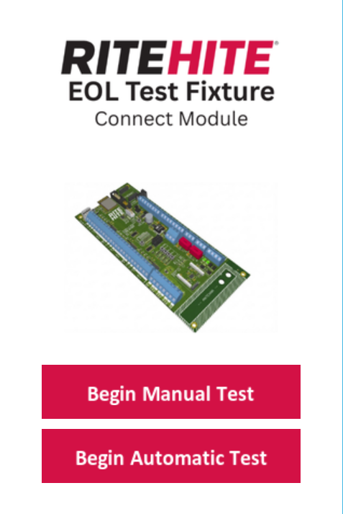

Purpose
Entry point to the fixture.

What You See
- Begin Automatic Test
- Begin Manual Test

What You Do
- Press Begin Automatic Test for the normal production test.
- Press Begin Manual Test only for service, debugging, or engineering checks.

What Happens Next
- Begin Automatic Test begins the production test and enters the Communication Test Screen.
- Begin Manual Test enters the Manual Configuration Screen.

Communication Test Screen
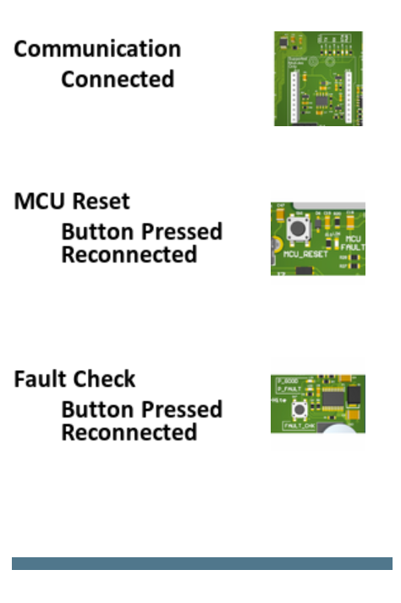

Purpose
Runs the first three fixture-controlled stages:
- Communication
- MCU Reset
- Fault Check

What You See
- The stage labels update as each sub-stage passes or fails.
- The progress bar advances through the three sub-stages.

What You Do
- Observe only.
- Do not disconnect the DUT, fixture USB, or programmer during this stage.

Result
- Pass: Fixture advances to Input Test Screen
- Fail: Fixture transitions to Fault Screen

Input Test Screen
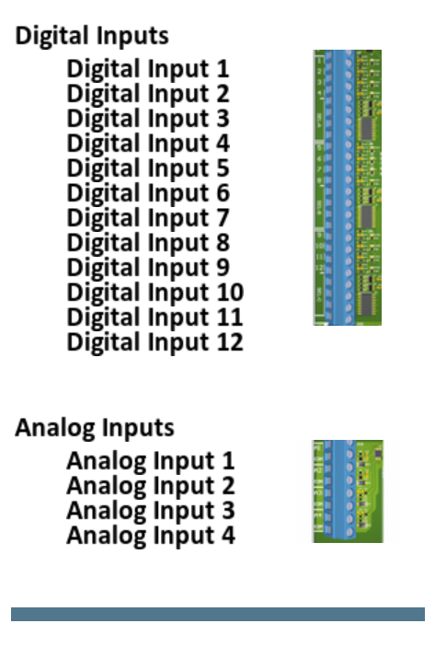

Purpose
Runs tests for:
- Digital Inputs
- Analog Inputs

What You See
- Individual input items turn green as they pass.
- The progress bar first covers digital inputs, then analog inputs.

What You Do
- Observe only.
- Do not interrupt the run.

Result
- Pass: Fixture advances to Output Test Screen
- Fail: Fixture transitions to Fault Screen

Output Test Screen
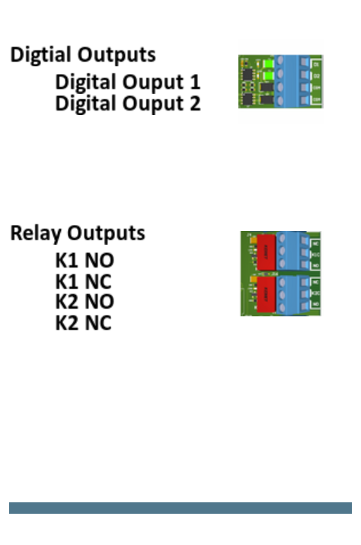

Purpose
Runs tests for:
- Digital Outputs
- Relay Outputs

What You See
- Digital Outputs and Relay Outputs are shown as separate sections.
- Relay items update as K1 and K2 ON/OFF checks run.

Current Revision Note
- Digital Output 1 and Digital Output 2 are temporary auto-pass report rows.
- Relay verification is live and can still fail.

What You Do
- Observe only.
- Do not interrupt the run.

Result
- Pass: fixture advances to Button & LED Test Screen
- Fail: fixture transitions to Fault Screen

Button & LED Test Screen
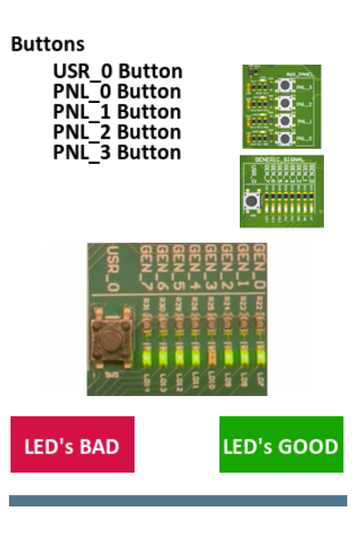

Purpose
Runs the final automatic button sequence and the final manual LED decision.

What You See
- Button labels for USR_0, PNL_0, PNL_1, PNL_2, and PNL_3
- LED image / animation area
- LED's BAD
- LED's GOOD

Important Current Behavior
- The fixture automatically drives the button sequence by toggling its output lines and checking the ESP32 replies. Do not attempt it manually during the normal automatic test.
- The technician only makes the final visual LED decision. The test will wait until the decision.

What You Do
- Watch the button stage complete automatically.
- When the LED review begins, look at the LED pattern on the fixture.
- Press LED's GOOD if the LED behavior is correctly matches the rotation shown on screen.
- Press LED's BAD if the LED behavior is incorrectly matches the rotation shown on screen.

Result
- LED's GOOD: Fixture advances to Test Complete Screen
- LED's BAD: Fixture transitions to Fault Screen

Fault Screen
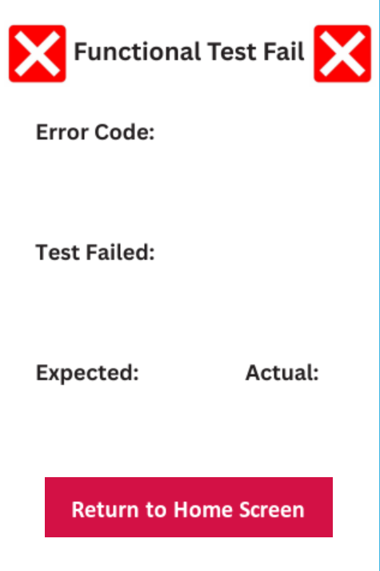

Purpose
Final fail screen for the current run.

What You See
- Hex error code (i.e. 0x0xxx)
- Failed test or step name
- Expected value or condition
- Actual value or condition

What You Do
- Record the error information required by your process.
- Use EOL Test Fixture Error Code Reference and EOL Test Fixture Troubleshooting Guide.
- Export the failed run.

Test Complete Screen
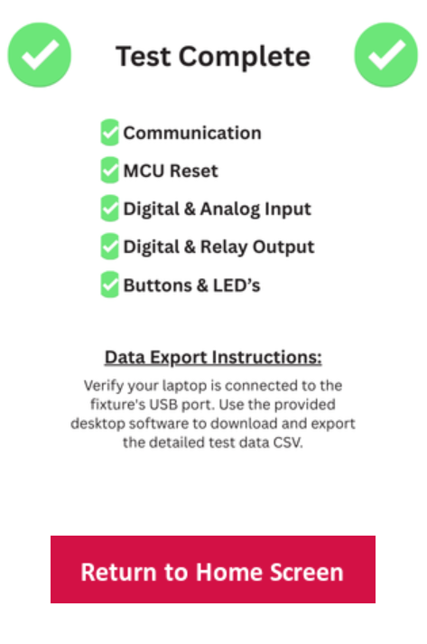

Purpose
Final pass screen for the current run.

What You Do
- Record the board or unit as passed.
- Export the run, or confirm that One Click exported it automatically.

Manual Configuration Screen
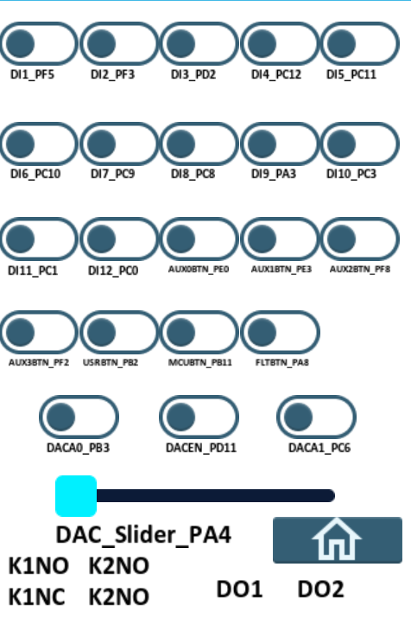

Purpose
Manual service and debug screen reached from Begin Manual Test for engineering purposes.

What You Can Control
- DI1 through DI12 outputs
- AUX0 through AUX3 button outputs
- USR, MCU, and Fault control outputs
- DACA0, DACA1, and DACEN
- DAC output slider

What You Can Read
- K1NO, K1NC, K2NO, K2NC, DO1, and DO2 input readback

What You Do
- Use only for maintenance, debug, or engineering-directed verification.

EOL Export Software Screens

File Explorer
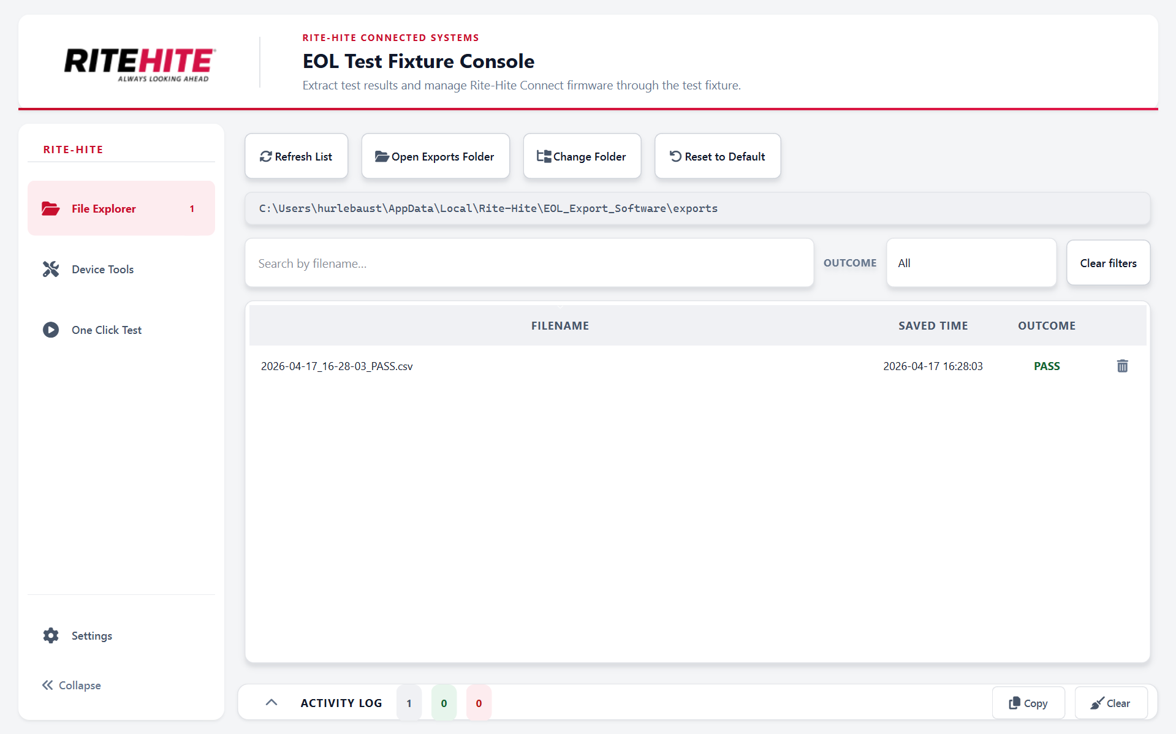

Purpose
Shows exported .csv files. Allows the technician to open them and manage the export folder.

What You See
- File list of exported data in .csv format
- Search box
- Outcome filter
- Buttons to refresh, open the folder, change the folder, or reset to default

What You Do
- Confirm the expected .csv exists after export.
- Open or sort historical exports as needed.

Device Tools
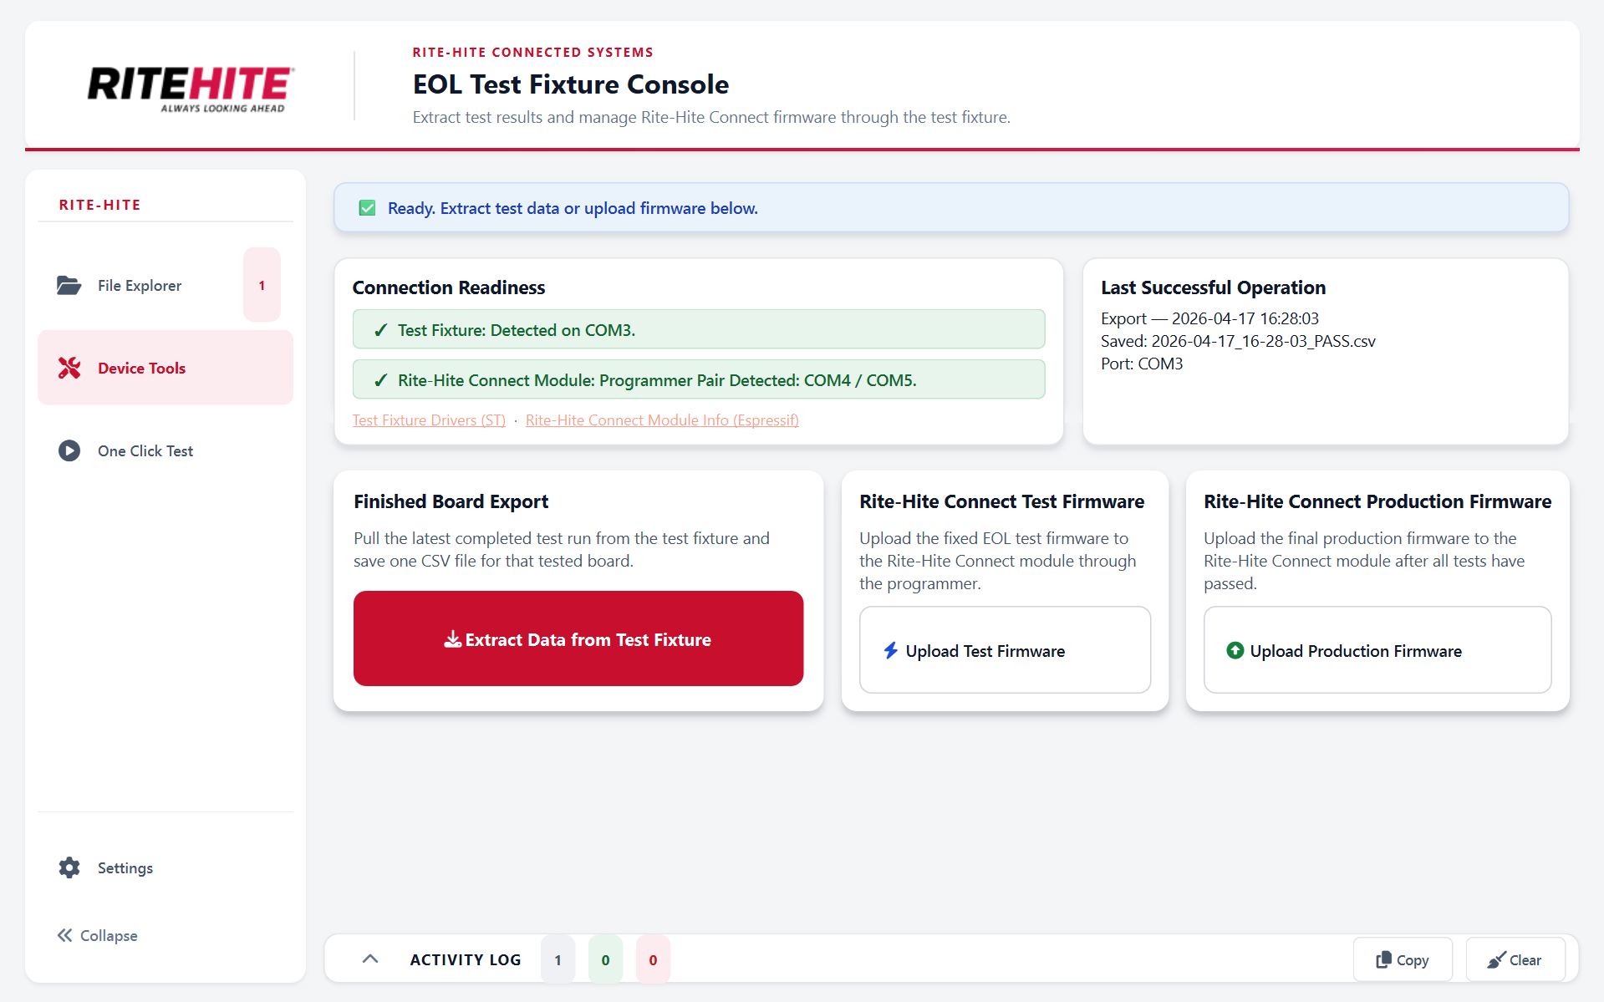

Purpose
Provides the manual PC-side operations.

What You See
- Connection Readiness card
- Last Successful Operation card
- Extract Data from Test Fixture
- Upload Test Firmware
- Upload Production Firmware

What You Do
- Use Extract Data from Test Fixture after a normal touchscreen run to save the latest pass or fail report as a .csv data format file.
- Use Upload Test Firmware to load the fixed Rite-Hite Connect Module test firmware.
- Do not expect Upload Production Firmware to work yet; A coming soon message is shown.

One Click Test
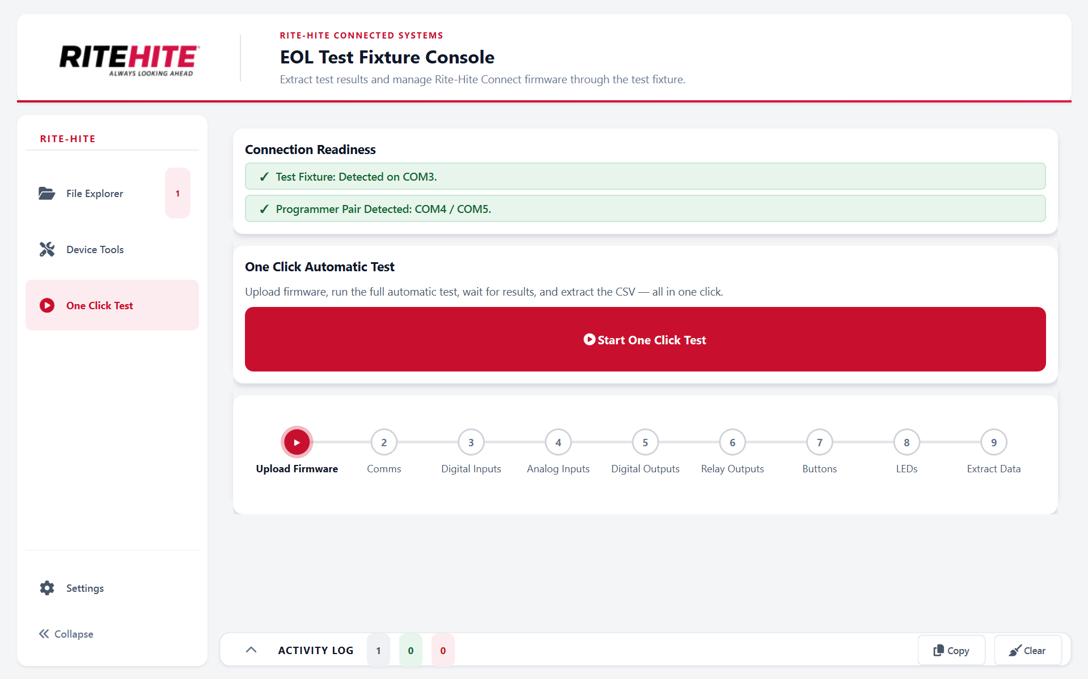

Purpose
Runs the full PC-assisted workflow in one action.

What You See
- A connection-readiness card for the fixture and programmer
- A large Start One Click Test button
- A live progress rail: 1. Upload Firmware 2. Comms 3. Digital Inputs 4. Analog Inputs 5. Digital Outputs 6. Relay Outputs 7. Buttons 8. LEDs 9. Extract Data

What You Do
- Confirm the fixture and programmer are detected.
- Press Start One Click Test.
- Watch the Activity Log and progress rail.
- When the app indicates technician action is required, go to the fixture and press LED's GOOD or LED's BAD after evaluation.
- Confirm the .csv is saved at the end.

How It Behaves
- The progress rail follows the real EOL Test Fixture phase (test state), not a fake timer.
- The current phase is red.
- The previous phase turns green when the next phase starts.
- Manual extract and manual test-firmware upload are locked while One Click Test is running.

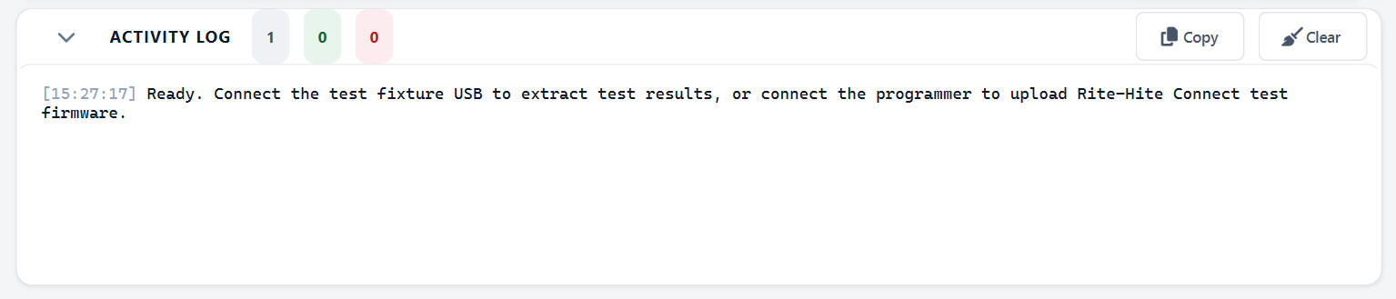
Activity Log

Purpose
Shows the detailed live log for uploads, One Click Test progress, prompts, and exports.

What You Use It For
- Confirm what step is active
- See upload progress
- See export completion
- See One Click Test prompts such as the LED visual confirmation request

Settings
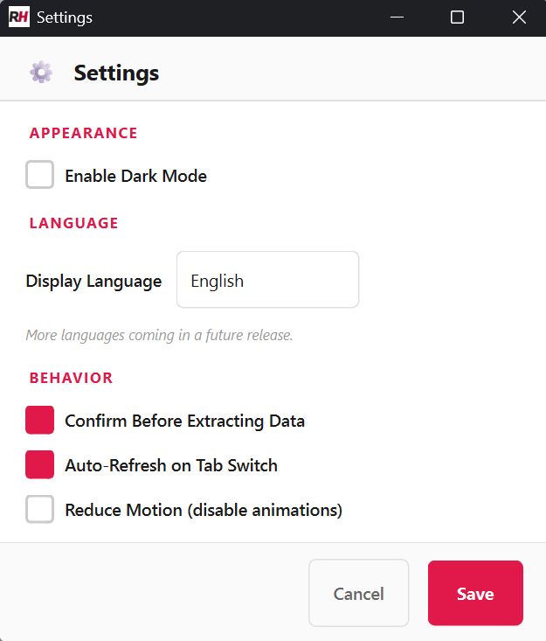

Purpose
Stores local app preferences.

Available Settings
- Language
- Confirm before extract
- Auto refresh on tab switch
- Reduced motion
- Dark mode setting
The export folder path is managed from File Explorer and stored locally on the PC when it is changed.

Language Support
The app includes:
- English
- Spanish
- Hmong

